

- Im a starting this new thread to help newbies like me to add to our ever growing need to learn and grow. Not to compare and judge but to expand our knowledge in this exciting new era of electronic fx trading where anyone can participate to trade forex and transform their lives forever.

- Wait until a new candle emerges. Add 1pips + spread above or below the S&R.
Regarding trailing stop, it all depends on the currency pair. Anything with YEN, usually demands min of 30TL. EURGBP usually need only 10, and most other pairs 15. This is my usual TL, fm experience.

- Break the profit target into 3, T1, T2, T3 in this percentage 70%, 20%, 10%. T1 is 5pips, T2 is the next 10pips and T3 is up to you. Move your stops accordingly. Should it reverses, losses is truly minimise.
- With the 3 pairs i recommended, it is very rare to have such reversal. In order to understand this method (using S&R), S=R. Take a scenario during an infantry (war) invasion. Imagine when the British wants to attack the Germans. The British army either has to attack France or Belgium 1st in order to get into Germany. They cannot swiftly attack both countries without any resistance. But when they succeed, they will eventually attack the Germans.
- Pardon my example. Like S&R, the price will take time to penetrate the S&R, they (the British Army) might have to go back to the nearest base to get some more ammunation again & again, but eventually when they succeed in breaking the resistance/Support they USUALLY wont retreat, they will move forward quiet far!!
- Like i said, with the Daily candle, WHEN IT PENETRATES, IT PENETRATES! Minimum around 5pips + spread. A good enough trade in terms of quality pips.

- When anyone straddle the small weekend daily candle, definitelly all 3 pair gives more than 5 pips each.

- Thanks for the compliment and I agree 100% about discreaniary trading (manual) is always better than Robot trading (EA). The question is, For how long? Ever read book by Robert T. Kiyosaki, The cash Flow Quadrant? It talks about generating passive income is better than active income.
I am trading manually and making $$ with it, but what happens when I choose to retire? Even when the EA gives only 10% a month, I will be happy, at least I can use my othertime doing other things that I really wanted to do.
This is what this tread is about. A forum for new and experience trader to help me build an EA based on a successful system. I give my system, the forum give me an EA. Everybody's happy. A well paid 2way charity.

- The most successful trader I know are using simple tool and basic techniques. The thing about S&R sre, when it penetrates it penetrates, but when it doesnt, it usually stay right on the border. Thats why TP is very viable when your entry is from yesterdays open or close. Simple works.

- GBPUSD is the most volatile of all, 30-50sl should do it
EURUSD is amlost like cable but a bit sober
AUDUSD is really downunder, 25-35sl usually is ok.
However, remember when you are aiming 5pips only, try and trade on Monday & friday (except this friday) to harvest maximum pips. It might help you to recover some losses just in case the pairs went into extacy and stooped your sl.

- Trendlines will help you reap more pips than you normally do. Not many have the discipline to follow it. Learn it from the Master Jedi himself. Jedi ROB Booker! here it is:
http://www.forexfactory.com/forexfo...9951#post129951

- AUDUSD is a very sober pair, movement is not erotic, just like their crocordiles, friendly bunch!! Traillock of 35 should get you maximum pips or at least a winning trade at the end.

- I use 1hr to enter and exit too. I can draw the high & low of yesterdays using the 1hr chart. This way, I can spot market sturucture and price action in macro.

- Ok, in forex trading, losing is part of the game. When you dont want to lose, move your stoploss to breakeven, it may cut your profit short, but winning quality pips are more frequent.

- Most newbies want to make a 100 pips in a week and expect to become millionaires next month! They try every available method they can get hold off without proper experience and understanding of T.A & Fundamentals that they are using and studied. And many times, newbies get burnt.

- Messa think this will helps. Written by John Kicklighter, Currency Analyst
The following is our monthly correlations update for October. As we have mentioned time and again before, correlations between different currency pairs will inevitably shift over time, therefore it is of utmost importance to keep abreast of these changes. Below are the one-, three-, six- and twelve-month correlations for the seven major currency pairs. Additionally, we have included the six-month trailing correlation versus the EURUSD as further confirmation of the correlation.
In order to be an effective trader, it is important to understand how different currency pairs move in relation to each other. There are a few reasons why this is significant, but most importantly, it allows traders to understand their exposure. That is, having a portfolio that consists of the EURUSD and GBPUSD is different than having a portfolio comprised of GBPUSD and USDCHF. As indicated in the tables below, over the past month, the GBPUSD has had a strong positive correlation (+0.89) with the EURUSD and a strong negative correlation with USDCHF (-0.91). Therefore having a long GBPUSD and long EURUSD exposure would generally lead to negated or nearly zero profit or loss because when the GBPUSD rallies, USDCHF will sell off the majority of the time. Of course, these two currencies have different pip values and the correlation is not perfect, so the P/L may not be exactly zero. On the other hand, holding long GBPUSD and long USDCHF exposures would be similar to nearly doubling up in one of the pairs since the correlation is so strong. Furthermore, we can tell from our tables that correlations shift with time. For example, the NZDUSD has historically held a statitistically weak negative correlation to the USDJPY (-0.28) over the past year. Just this past month, however, this relationship has developed to more relavant levels (-0.61). Shifts such as these can be partially explained by changes in the severity of monetary policy or changes in unique domestic conditions. Overall, having this knowledge will allow traders to effectively diversify and manage their portfolios.
Regardless of your trading strategy and whether you are looking to diversify your positions or find alternate pairs to leverage your view, it is very important to keep in mind the correlation between various currency pairs and their shifting trends.
FX Correlations (data as of 11/01/06)
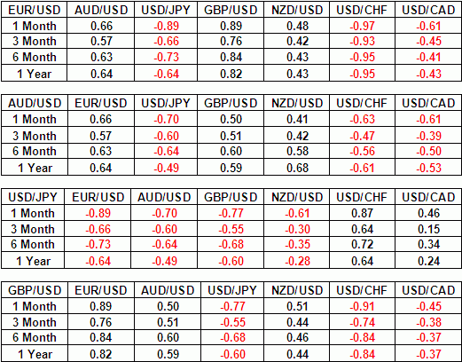
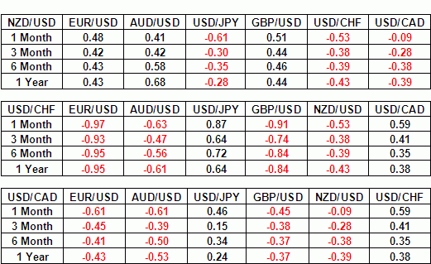
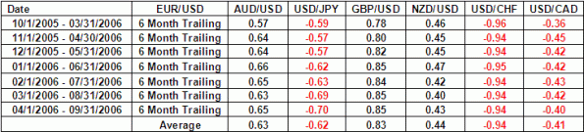

- Just remember this:
R:1.0000
Therefore Add spread + 1 to 2 pips. I sometimes even add 5pips. For this example, Spread is 2 and Margin is 2.
Pending buy stop is now: 1.0004. Your orders will be activated when it hits 1.0002 which when you check including spread at your orderbox is 1.0004.
They activate your orders on the actual price but on the order sheet is spread included. I suppose thats why we get -2 as we entered the trade.
When messa think this sounds complicated, do wat my 14yr old son did, just add 10pips on normal majors!! He is now the most loaded selfmade businessboy in his school with starting account of only USD500 last few months. He made an average of 350pips a month on the 3 pairs. Setting pending orders before he goes to school.
- Yes, ADR & ATR can help. But the problem with thse things, like fundamental studies, when you interprete and understand it wrongly, the result may be that you can get sucked to the darkside.
- Ok, Trendline drawing is an art. There are many ways around it, and there is not 1 correct way, but beware, there are also many wrong ways.
In SRDC particularly, I drew (as the name apply) Support & resistance trendlines, which created a channel (parallel trendlines). This way, i can find out whether the pair will change trend (when it penetrate the trendline) and to see what the range of the pair (by calculating the channel distance) and to see where is the most probable price movement of the next candle (by dividing the channel into 2; the mid trend line).
- When the price is near to daily or weekly highs or lows. The price usually bounce erotically before 2 things happen: 1) penetrate, 2) Not penetrate.
This usually hit your stoploss even when the trend is in your favour EVENTUALLY. Explaination: Traders sentiment. So, beware, when in doubt, go call your cat, & spend the evening stroking HER. Just dont trade that day!
- Basic method is SRDC level 1. This method has been perfected with different levels. Yes, it is my method of trading. No, its not the full system. What i illustrate is basic coming to level 2.
We dont have to trade everyday. When there is no trade, then no trade. But remember, as you become familiar with the method, a no trade 2day, means a bigger pips the next day as the candle will be much longer than the previous.
- In a broader sense, to me Discipline is an act of thinking. It can be divided into parts:
Humble, Respect, Knowledge, Practice, execution of trades, Consistency.
Risk or Money management is a big part of discipline, and falls under Knowledge, practice, execution of trades and consistency. That is why it is very important. Skill can be learnd but disciple can only be mastered.
an example of discipline in terms of execution of trade, would be "always respect the market. When trend is your friend, Market is your best friend! Market would gives you opportunity to make money from him, not everytime. To make sure market gives you pips, Be kind to the market. Dont force entries into the market, he will be offended and curse you".

- I havent complied the rules in a standard manner, coz im so used to seeing the candles, a glance will click my thoughts to draw it. But, I will try to simplify it below.
Rules on 1hr:
1. Use Euiqdistant Channel to contain the latest trend within the channel
2. 1 day channel is not very accurate
3. 2 days channel will show a trend
4. 3 days channel will complete a channel.
5. Find the Highs of the 1-2-3days and the lows which touches the trendline the most!! = Channel. An extreme H & L may not count!!
6. Adjust as the next day candles finish forming.
7. Draw a Median (parallel to the Channel)
8. A perfect channel will be when you can draw, the start and end of day to be near or on the median. However sometimes this is not possible. The nearer the median to the day start and end the better.
9. use the end of day saperator.
10. Use candles & Bear black and bull white when possible. And light background so Jedi dont have wear glasses!! LOLHow to apply to SRDC? When the candles is near to the channel (H 0r L), the chances of it breaking the trend is slim (unless a trend change). So, the only probable direction is towards the median and the opossite trendline.
See the prvious day's H & L (S&R). Since you have establish a probable direction, it is only logical to enter a trade following this direction. Early entry will be possible without waiting for it to break the previous H & L (actually this is part of level 2 explaination).
In the case of price near the trend line (H&L), T1 is the Median & T2 is break of previous day's H&L (S&R) and T3 is the opposite Trend. Proper Money Management will satisfy your lust for Jaba's GF, oppss sorry I mean positive pips!!
The rest is reversal!! When you can master this method, a day range can produce pips equal to 1 day range x 1.5. Eventually, the price will goback to the median again at end of the day!!
Understand the above statements, and SRDC level pandora's box is open!!
- A stoploss is not necessarily a win/loss ratio But more importantly to keep your trade a winning one, which in this case Stooped-out on a temporary trend change before following the original trend.

